**Problem Set 2 Macroeconometrics**

**Question 2**

1. ***Can we apply OLS to the structural VAR? Why or why not?***

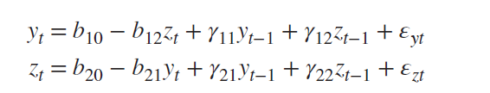

In general, we cannot apply OLS in the Structural VAR because the model incorporates feedback, that is, the model suffers from simultaneity. Following the example, $Y_{t}$ affects $Z_{t}$ and, at the same time, $Z_{t}$ affects $Y_{t}$. Hence, if we apply the linear model to one of the equations, there will be a problem with biased estimates. As we have simultaneity, the regressors and the error terms would be correlated, breaking the OLS assumption of exogeneity. In this case, we would have $cov\left(Z_{t},ϵ_{yt}\right)≠0$ and $cov\left(Y_{t},ϵ_{zt}\right)≠0$, creating biased estimates. Then, in order to solve this problem, econometricians use the reduced VAR to make the estimates, guaranteeing that there will be no problems with endogeneity. However, this algebraic transformation implies difficulties in interpretation that require different strategies to overcome the problem, such as recursive VAR or Cholesky decomposition.

1. ***Can we interpret the reduced form errors of the VAR? Explain.***

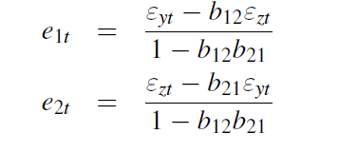We cannot directly interpret the coefficients of VAR since they are a linear combination of the structural errors. Hence, we are not able to directly understand the impact of a specific shock.

For us to be able to interpret the shocks, we must retrieve the structural ones. To do so, we shall use the recursive VAR or Cholesky decomposition. As the reduced VAR model has fewer parameters than the structural VAR we must make assumptions. In case of a system with two equations, we must assume that **only one** of the variables **affects the other simultaneously**, which in practice implies setting $b_{12}=0$ or $b_{21}=0$. In case we are dealing with a system of three equations, we would be assuming that the first variable is only explained by itself contemporaneously, the second is explained by itself and by the first one and the third variable is explained by all others, contemporaneously. Hence, in general, for us to be able to identify the structural model, we always need $\frac{n^{2}-n}{2}$ restrictions. To conclude, although we cannot directly interpret the shocks of the VAR model, we can retrieve the initial model setting a number of restrictions regarding the way that the variables affect each other contemporaneously.

1. ***Can we use VAR models to infer causal relationships? Explain.***

Although VAR models have been evolving a lot since 1980, they have numerous limitations and many econometricians continue to search for new methods and approaches. Regarding forecasts, the model is very strong. However, in what comes to the power of capturing causality there is a lot of uncertainty about the model’s capacity.

“What are the effects of a monetary policy intervention?”. Traditionally, researchers tried to answer this question through a theoretical model, exploiting the causal relationships entailed by the model and using systems of equations with endogenous and exogenous variables to exploit the relationships. However, in 1970, Lucas criticized these approaches, arguing that economic theory was not enough to assume a variable as exogenous. He also argued that in fact, most of the models had a huge problem: not considering that agents could predict policy intervention. Hence, at this time, models were, in general, far away from capturing causality between variables.

Later, Wiener and Granger tried to follow a different approach, avoiding relying on previous macroeconomic theory and trying to focus more on the statistical properties of the data, but it also has problems and flaws because it focus on the reduced form model, not capturing the “structural causality”.

VAR models are in the middle of theses two approaches. VAR tries to grasp the “structural” correlations but using a reduced form model to the estimation. However, the model is not able to avoid the theory, once that the ability of retrieving the structural coefficients relies on making important assumptions about the variable’s behavior.

To conclude, although VAR models gets us closer to causality, it still relies on assumptions that could be far from reality. Depending on the validity of the assumptions, the model could be closer or not to causation.